**Project Design Phase**

**Solution Architecture**

|  |  |
| --- | --- |
| Date | 24 June2025 |
| Team ID | *LTVIP2025TMID52072* |
| Project Name | Learn Hub |
| Maximum Marks | 4 Marks |

🧠 Solution Architecture

Solution architecture bridges the business need for an efficient, modern, and scalable e-learning platform with a robust technical solution. For LearnHub, the architecture is designed to ensure:

* Secure and seamless delivery of educational content
* Support for role-based access (students, teachers, admin)
* High availability and scalability for future expansion
* Easy maintainability and deployment with modular design

🎯 Key Objectives:

* Map functional requirements (like registration, course creation, video streaming, etc.) to modular components.
* Design a scalable 3-tier MERN (MongoDB, Express, React, Node) architecture.
* Ensure flexibility in deployment (local/dev/prod) with environment-driven configurations.
* Define clear boundaries between frontend, backend, and database services.

🧱 Architectural Diagram (Conceptual View):

I’ll describe the architecture for now. Let me know if you’d like me to generate a diagram for this.

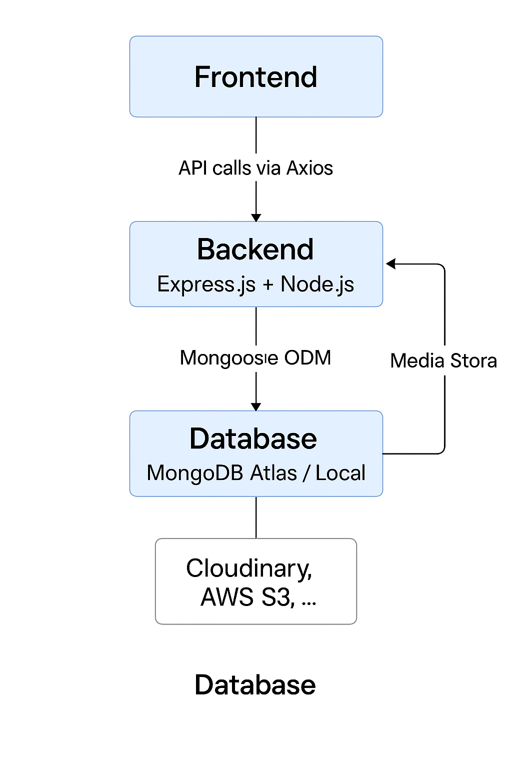🖼️ Sample Data Flow:

1. User accesses the React frontend
2. Frontend communicates with backend via REST APIs (e.g., /api/auth/login, /api/courses)
3. Backend authenticates using JWT and handles business logic
4. Backend interacts with MongoDB for user, course, and progress data
5. Media files (video lectures) can be stored in cloud (e.g., Cloudinary, AWS S3, or local)

🗂️ Key Modules:

| **Layer** | **Modules** |
| --- | --- |
| Frontend | Auth pages, Course Player, Teacher Dashboard, Admin Panel |
| Backend | Auth APIs, Course APIs, Enrollment Logic, Role-based Access Middleware |
| Database | User Schema, Course Schema, Enrolled Mapping, Progress Tracking |

🔒 Security Features:

* JWT-based authentication
* Role-based route protection (teacher/student/admin)
* Encrypted password storage (bcrypt)
* Secure headers and CORS configuration

📦 Deployment Readiness:

* All environment-dependent URLs (BASE_API) are modular
* Frontend and backend separated for CI/CD integration
* Supports local MongoDB and MongoDB Atlas
* Can be deployed to Render, Railway, Vercel or any cloud platform